WIPRO TALENTNEXT PROGRAM
PBL HANDS-ON ASSIGNMENT
Name: M.VINAY
Roll No: 23BQ1A4951
PBL ID:DB_262790141
Date: 17-07-2026
Topic: Introduction to SQL( displaying data from multiple data)

1. Addresses of all departments using EMP and DEPT tables, showing EMPNO, ENAME, SAL, DNAME, LOC — NATURAL JOIN.
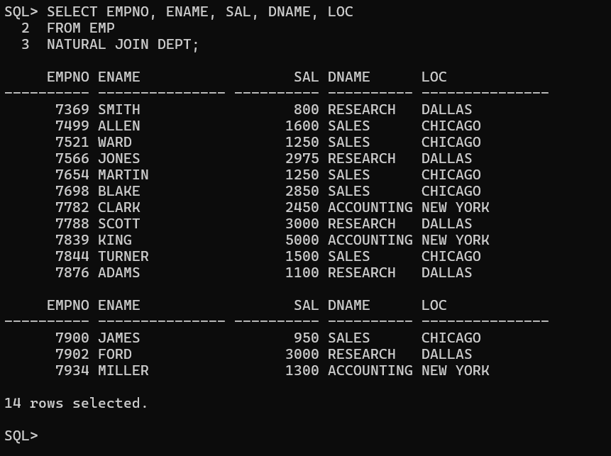
2. JOB, MGR, SAL, COMM, DNAME for employees whose JOB is SALESMAN — Equi Join.
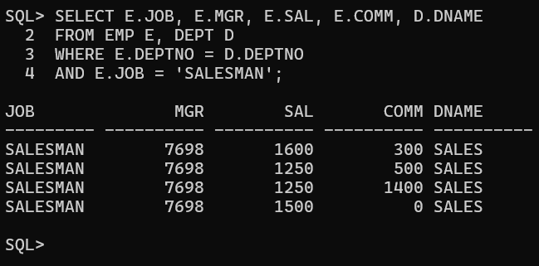
3. ENAME, job, DEPTNO, DNAME for employees who work in DALLAS — Equi Join.
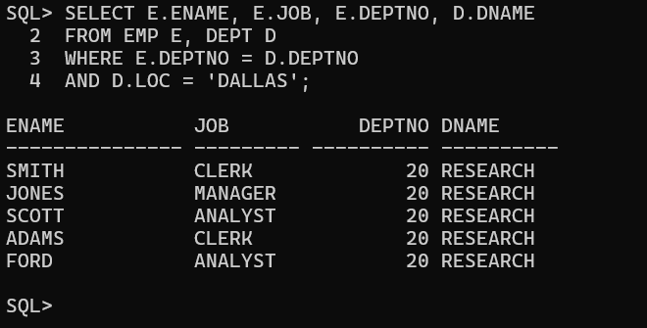

4. Employee's ename & empno with manager's name & number — Self Join. Labels: Employee, Emp#, Manager, Mgr#.
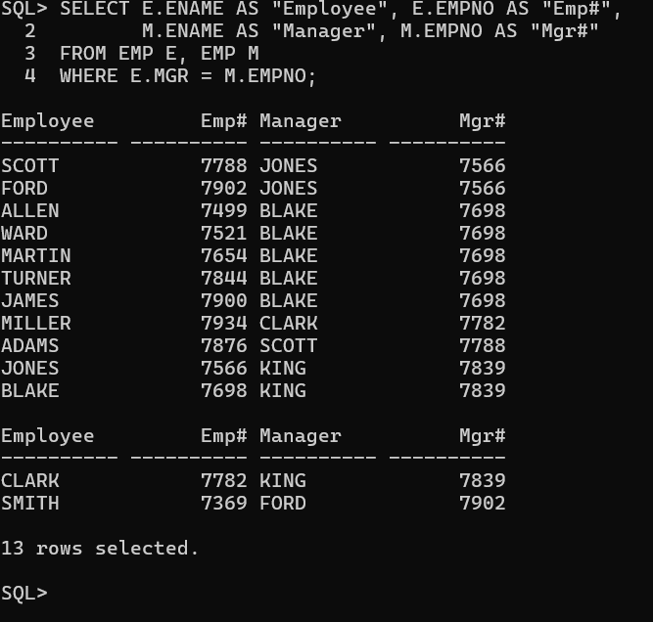

5. Modify to include KING (no manager) — Outer Join, ordered by employee number.
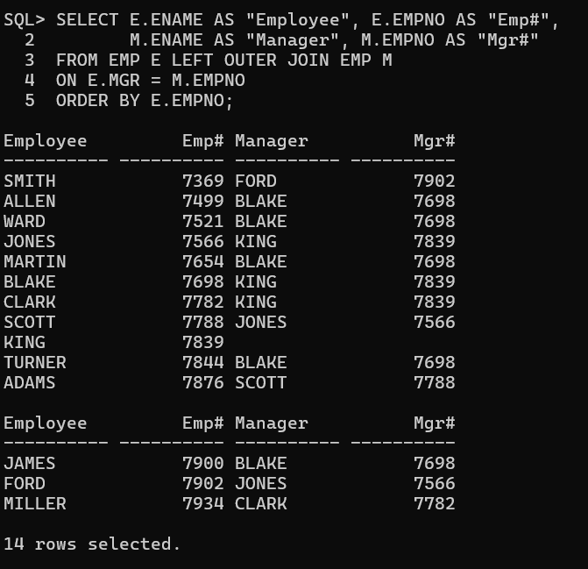
6. Name, job, department name, salary, and grade for all employees — Non-Equi Join with SALGRADE.

7. ENAME, DNAME of all employees, plus departments with no employees — Outer Join.
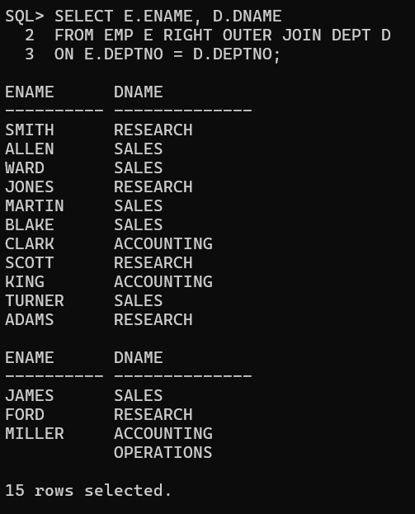

8. Names and hire dates of employees hired before their managers, with managers' names and hire dates — Self Join with Outer Join.
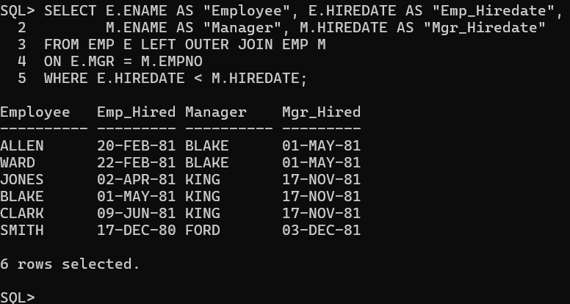
9. EMPNO, ENAME, DNAME, LOC for CLERK employees — USING clause.
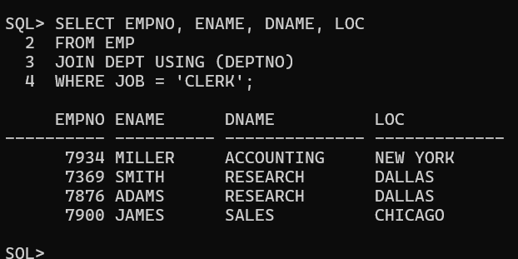
10. ENAME, SAL, MGR, DNAME for employees earning more than 2000 — ON clause.
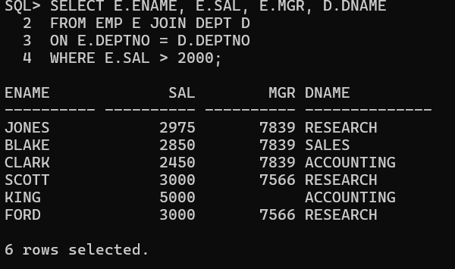

11. EMPNO, ENAME, JOB, DEPTNO, DNAME, LOC — LEFT OUTER JOIN.
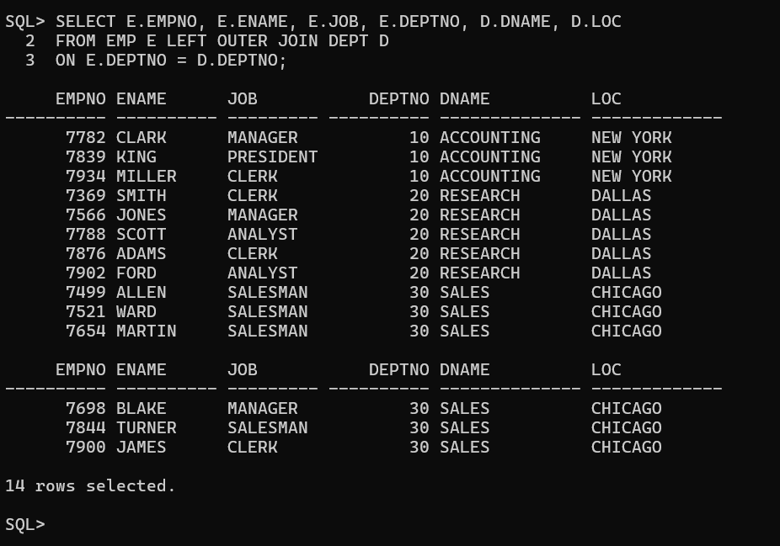

12. ENAME, DNAME — RIGHT OUTER JOIN.
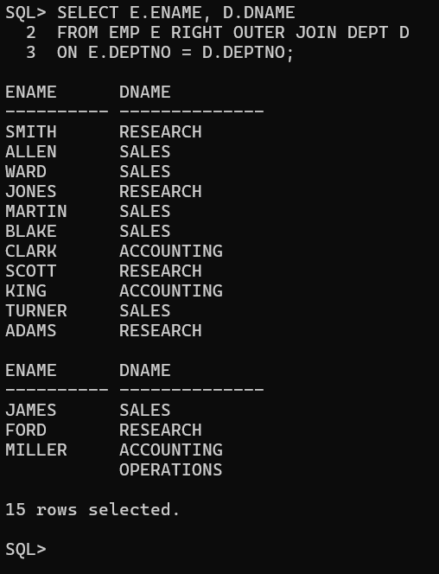

13. EMPNO, DNAME, LOC — FULL OUTER JOIN.
